Curriculum Vitae

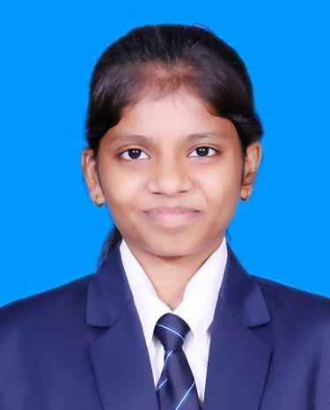

**Name**: Priyanshi Agrawal

**Mob:**8439484414

**Email:** [agrawalpriyanshi2577@gmail.com](https://d.docs.live.net/1d3148d8efb977e5/Desktop/agrawalpriyanshi2577@gmail.com)

**LinkedIn Id:** <https://www.linkedin.com/in/priyanshi-agrawal-6712312a5?>

**Github Id:** **[Priyanshi2577 (Priyanshi Agrawal)](https://github.com/Priyanshi2577)**

# Career Objective

To serve in an organization where my knowledge and skill scan be utilized for the growth of the organization.

# Education Qualification

|  |  |  |  |  |
| --- | --- | --- | --- | --- |
| **Standard** | **Board/University** | **School/College Name** | **Year of Passing** | **Division& Percentage** |
| B.C.A. | Chhatrapati Shahu Ji Maharaj University | Pranveer Singh Institute of Technology (PSIT-CHE) | 2026 | 8.2(Till 2nd Semester) |
| Intermediate | UP board | Mahatma Gandhi Balika Inter College Firozabad | 2023 | 69.5% |
| High School | Up board | Mahatma Gandhi Balika Inter College Firozabad | 2021 | 75.81% |

**Professional Certification**

* **Infosys springboard (HTML5)**
* **Infosys springboard (CSS3)**
* **Infosys springboard (JavaScript)**
* **Infosys springboard (C)**
* **Infosys springboard (C++)**
* **Infosys springboard (Python)**
* **Hackerrank(Problem-Solving(Basic))**

**Project**

* **Student Innovation SIH Project**
* **Personal Portfolio:**[**https://priyanshi2577.github.io/Portfolio/**](https://priyanshi2577.github.io/Portfolio/)

# Seminar/Conference/Workshop/Webinar

Attended International Conference & Seminar held at our college, PSIT-College of Higher Education.

# Awards & Achievements

|  |  |
| --- | --- |
| **Soft Skills** | **Technical Skills** |
| * Problem Solving * Team Work * Time Management * Leadership * Project Management * Active Listener | * C, C++ * HTML5, CSS3, JavaScript * Operating System * Data structure * Digital Electronic |

# Co-curricular Activities

# Participated in Internal Smart India Hackathon(2024)

# Participated in International Conference (2024)

# Hobbies& Interests

# Coding

# Sketching

# Crafting

# Writing

# Dancing

**Personal Details**

**Father’s Name: Sandeep Agrawal**

**Address: 103/12 Gandhi Nagar Firozabad**

**DOB: 25/08/2007**

**Gender: Female**

**Marital Status: Unmarried**

**Language Known: Hindi, English**

# Declaration

I hereby declare that the information furnished above is true to the best of my knowledge and belief.

**Place:** Kanpur **Signature**

**Date:** **(** Priyanshi **)**